Local LLM-Based PDF-to-Dashboard Pipeline for Human Development Analysis (Montenegro2009)

Student Name: Yash Ajit Salve Student Id: 24148273

For all the results, code, documentation here is the Github link – click here

1. Introduction
United Nations Human Development Reports combine data and analysis to assess national development. In this project, we built a local large language model (LLM) pipeline that turns the Montenegro National Human Development Report 2009 PDF into an interactive dashboard. The pipeline extracts, summarizes, evaluates, and visualizes structured information with local LLMs, and shows all results in a Streamlit dashboard.
The main goals of this project are to extract structured information, check the results with another local LLM, and show the findings in an interactive dashboard.

2. Methodology
The project follows a step-by-step process, beginning with text extraction from PDFs using PyMuPDF. Next, the text is cleaned and divided into smaller sections so local LLMs can process it more efficiently. Llama 3 is used to summarize, analyze themes, and identify key indicators. Mistral reviews these results by comparing them with the original text. All extracted data is saved in CSV, JSON, and text formats, and then displayed in an interactive Streamlit dashboard with charts, tables, and summaries.
This pipeline helps turn a complex, unstructured UN Human Development Report into clear, organized information that is easy to analyze and visualize. There are five main steps: extracting text from the PDF, cleaning and preparing the text, using prompts to find information, checking the results, and bringing everything together in a dashboard. Each step is independent, making the system easier to update and reuse in the future.

2.1 PDF Text Extraction and Preprocessing
We used the PyMuPDF library to process the Montenegro National Human Development Report 2009 and extract text from each page of the PDF. The extracted text had issues like inconsistent formatting, extra spaces, page numbers, and line breaks because of the original layout. To fix this, we added a preprocessing step to clean up the text by normalizing spaces, removing unwanted formatting, and making it ready for language model processing.
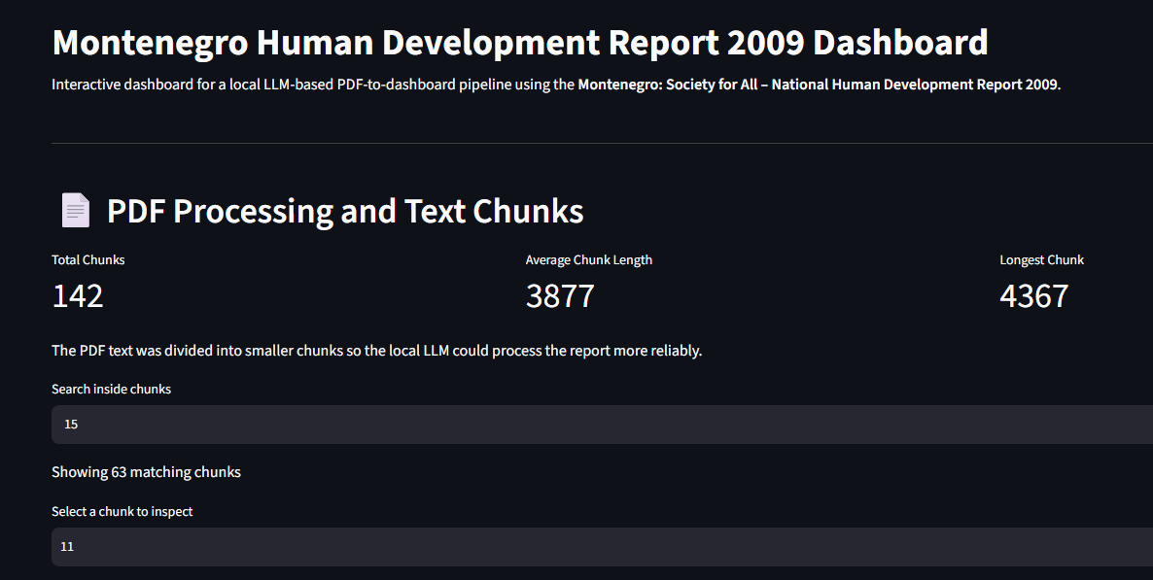
Since the report is more than one hundred pages long, we split the cleaned text into smaller sections before sending it to the local large language model (LLM). Breaking the text into chunks helps the model stay within its context limits and makes summarization and information extraction more consistent across the whole document.

Figure 1. PDF Processing page showing the generated text chunks and chunk statistics used for local LLM processing.

2.2 Local LLM Information Extraction
We analysed the cleaned text chunks using Llama 3, which ran locally through Ollama. We used prompt engineering to carry out several extraction tasks, such as:
- Report summarisation
- Chapter summarisation
- Theme identification
- Structured numerical indicator extraction
- Strength and challenge identification
Each prompt clearly explained the task, the expected output format, and any response limits. Using structured prompts made the results less ambiguous and easier to convert into CSV and JSON formats for later analysis.

2.3 Evaluation Framework
To make sure the model outputs were not evaluated by the same model that created them, a second local LLM (Mistral) was used to review the extracted information. The evaluation prompt asked the model to check:
- Completeness
- Consistency
- Factual alignment with the source text
- Clarity of the extracted information
Using a different evaluation model helps reduce self-assessment bias and adds another validation step before showing the extracted information in the dashboard.

2.4 Data Storage and Dashboard
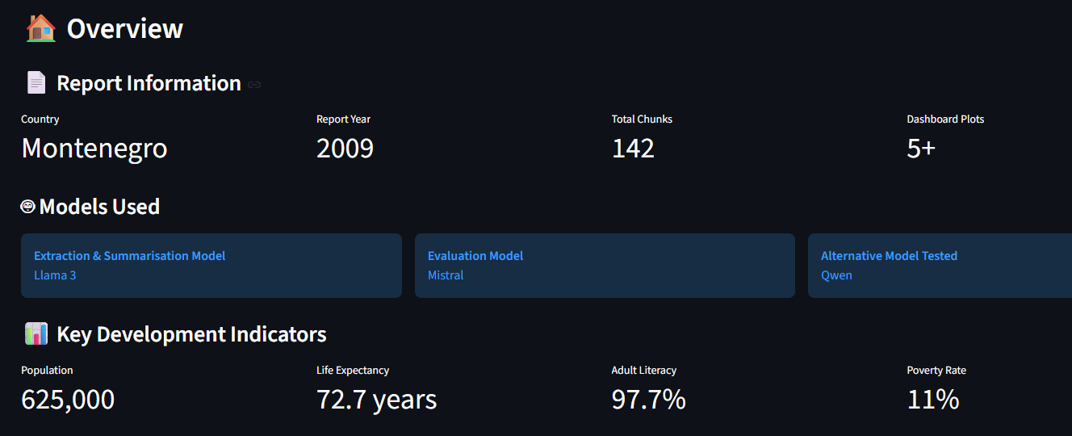
The extracted outputs were saved in several machine-readable formats such as CSV, JSON, and TXT files. These files were then used to fill an interactive Streamlit dashboard that shows theme distributions, development indicators, trends, chapter summaries, structured JSON outputs, and model comparison results.
Figure 2. Overview of the Streamlit dashboard presenting the extracted development information and key project metrics.

3. Prompt Engineering and Structured Information Extraction
3.1 Prompt Engineering
Prompt engineering helped the local LLM produce consistent, structured, and relevant outputs from the report text. Rather than asking for general summaries, each prompt set a clear task, output format, and limits like summary length or JSON structure. This made the instructions clearer and led to more consistent responses throughout the report.
The project used two types of prompts. The first type focused on extracting information and summarizing with Llama 3. The second type was for evaluating outputs with Mistral. By separating prompts for generation and evaluation, the pipeline could clearly tell apart content creation from quality checking.

Prompt 1 – Information Extraction (Llama 3)
Purpose: Generate concise summaries and extract structured information from report text.
Optimised Prompt
You are reviewing the Montenegro National Human Development Report.
Using only the supplied report text:
• Summarize the chapter in less than 100 words.
• Point out the main development themes.
• List the key numerical indicators.
• Present information in a structured way whenever you can.
• Only use information that appears in the report.
Why this prompt was selected
This prompt makes the extraction task clear and keeps the model focused only on information from the report. By setting a summary length and asking for structured outputs, it cuts down on extra explanations and helps keep numerical extraction consistent in different parts of the report.

Prompt 2 – Output Evaluation (Mistral)
Purpose: Evaluate the quality of the extracted outputs.
Optimised Prompt
Compare the extracted output with the original report text.
Evaluate:
• Completeness
• Consistency
• Factual alignment
• Clarity
Why this prompt was selected
Instead of asking the model for a general opinion, the evaluation prompt sets clear assessment criteria. This approach makes the evaluation more structured and consistent, and it helps spot missing details or differences between the generated output and the original report.

3.2 Structured Information Extraction
The prompt-based extraction pipeline created several machine-readable outputs, such as report and chapter summaries, thematic distributions, structured numerical indicators, and lists of development strengths and challenges. These outputs were saved as CSV, JSON, and TXT files so they could be reused for visualisation in the Streamlit dashboard.
The extracted indicators covered important development measures like population, life expectancy, literacy rate, gross enrolment rate, GDP per capita, poverty rate, and HDI values. Storing these values in structured JSON made later processing easier and reduced manual data entry when creating charts and dashboard components.
Overall, the prompt engineering strategy gave consistent results for most extraction tasks. Sometimes, manual checks were needed for numbers and JSON formatting, but using well-designed prompts along with a separate evaluation model made the extracted information more reliable.
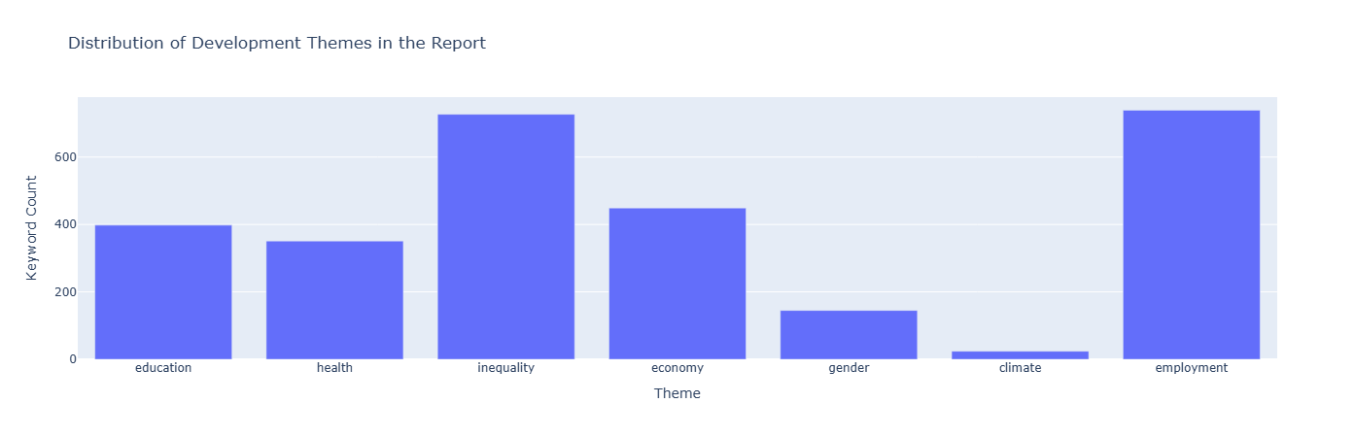

Figure 3. Distribution of development themes identified from the Montenegro Human Development Report.

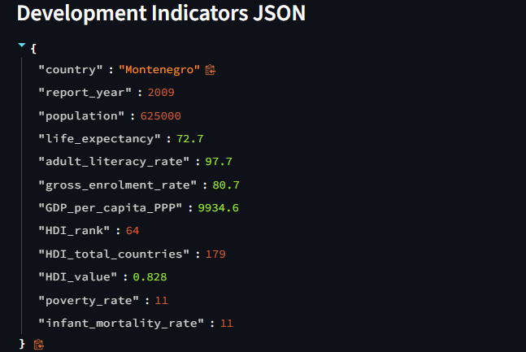

Figure 4. Example of structured JSON output generated by the local LLM for downstream analysis.

4. Results, Visualisation and Dashboard
4.1 Development Indicators and Trend Analysis
The structured extraction process found several quantitative development indicators in the Montenegro Human Development Report. These indicators give a clear picture of the country's development and show that local LLMs can reliably turn unstructured narrative content into structured numerical data for further analysis.
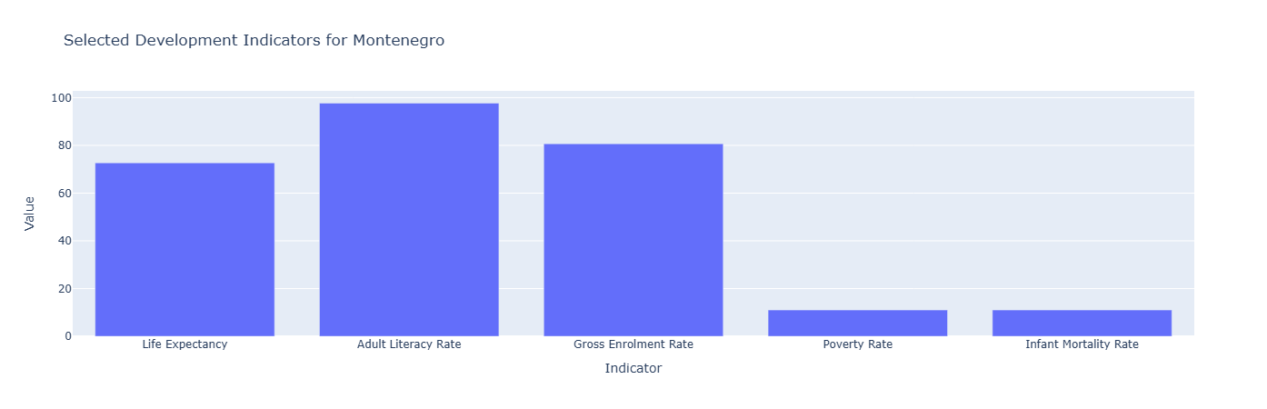
Figure 5. Selected development indicators extracted from the Montenegro Human Development Report 2009.

The data shows that Montenegro had a high adult literacy rate of about 98% and a gross enrolment rate near 80%. This suggests that education was a strong area of development during the reporting period. Life expectancy was around 73 years, which is positive compared to many developing countries. At the same time, poverty and infant mortality rates were low, showing better healthcare access and living conditions, though some groups still faced socio-economic challenges.

HDI Trend Analysis
To show how extracted numerical data can be used in visual analytics, the Human Development Index (HDI) values were arranged as a time series and displayed in the dashboard.

The HDI trend shows a steady rise over the reporting period, with only small changes in the early 2000s. This upward pattern points to ongoing progress in education, health, and the economy. While there are some year-to-year differences, the long-term trend is positive, which supports the report’s conclusion that Montenegro made steady gains in human development during this time.

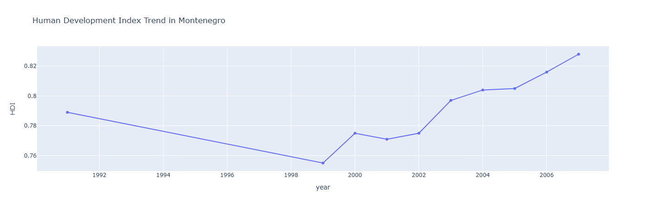
Figure 6. Human Development Index trend extracted from the report.

4.2 Interactive Dashboard

We brought the extracted information into an interactive Streamlit dashboard to make it easier to access and explore the results visually. Instead of just showing static tables, the dashboard brings together structured data, charts, summaries, JSON outputs, and model evaluation results in one place.
The dashboard includes:
- PDF processing statistics and text chunk viewer
- Development theme distribution
- Structured development indicators
- Key strengths and development challenges
- Chapter summaries
- HDI trend visualisation
- Structured JSON outputs
- Cross-model comparison
- LLM evaluation results
The dashboard is modular, so you can look at each part of the extraction process on its own. At the same time, it keeps a clear link between the original report, the extracted information, and the visualizations.

5. LLM Evaluation and Discussion

5.1 Cross-LLM Behaviour Analysis
This project aimed to compare how different local LLMs perform extraction and evaluation tasks. We tested three models: Llama 3, Mistral, and Qwen. While all three could summarise reports and extract structured information, we noticed differences in response quality, consistency, and how well they followed the requested output format.
We chose Llama 3 as the main extraction model because it consistently gave detailed summaries, accurately identified development themes, and produced structured outputs that needed little post-processing. It also followed instructions well and kept good context even in long report sections.
We picked Mistral as the evaluation model because it gave concise and objective assessments when comparing outputs to the source text. Using a separate model for evaluation helped avoid self-evaluation bias and added another check for completeness, consistency, and factual accuracy.
Although Qwen generated reasonable summaries, it occasionally produced overly brief responses and sometimes failed to follow the requested output structure consistently. Consequently, it was retained only as an alternative comparison model rather than being used in the final extraction pipeline.

Table 1. Comparison of Local LLMs
Criterion | Llama 3 | Mistral | Qwen
Report Summarisation | Excellent | Good | Good
Structured JSON Extraction | Excellent | Good | Moderate
Theme Identification | Excellent | Good | Moderate
Prompt Adherence | Excellent | Excellent | Moderate
Evaluation Capability | Good | Excellent | Moderate
Overall Suitability | Best for Extraction | Best for Evaluation | Alternative Model

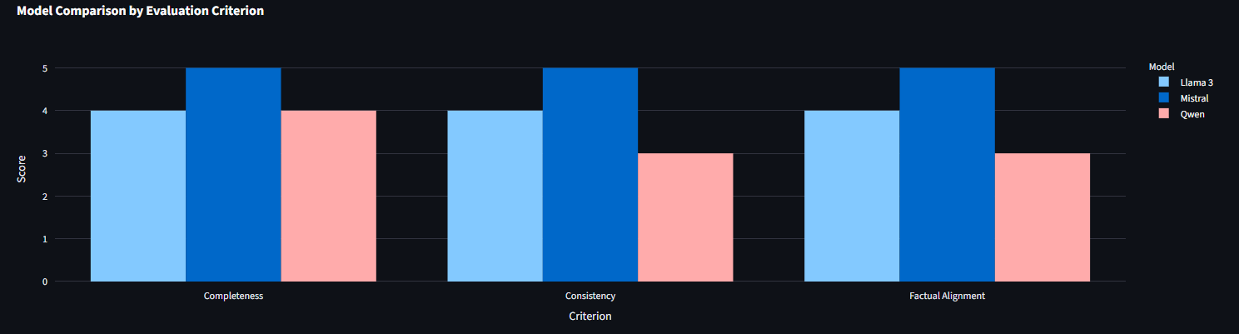
Figure 7. Comparison of local LLM performance across extraction and evaluation tasks.

5.2 Discussion

The results show that local LLMs can automate the extraction of structured development information from long policy documents. By using prompt engineering, document chunking, and structured output generation, the pipeline turned an unstructured PDF into machine-readable data ready for visualization and analysis.
A key strength of this approach is keeping information generation and evaluation separate. Using different models for extraction and assessment increased confidence in the results and made it less likely to accept inaccurate information without checking.
Using machine-readable outputs like CSV and JSON made the pipeline more flexible, since the extracted information could be reused for visualization and further analysis without extra manual work. The interactive dashboard made it easier to interpret results by showing both qualitative summaries and quantitative indicators together, so users could quickly explore different parts of the report. Comparing several local LLMs showed that choosing the right model affects extraction quality, especially for structured outputs and following prompts.

7. Conclusion

We built a local LLM-based pipeline that turns PDF reports into interactive dashboards, using the Montenegro National Human Development Report 2009 as a test case. The system handled a report of over 100 pages, breaking it into 142 text chunks. Llama 3 analysed these chunks, and Mistral independently checked the results. We extracted and visualised report summaries, chapter summaries, development themes, numerical indicators, and JSON files in a Streamlit dashboard with more than five analytical views. Key indicators included an HDI of 0.828, 97.7% adult literacy, 72.7 years life expectancy, and an 11% poverty rate, showing the pipeline can accurately extract numbers. Comparing models, Llama 3 gave the most consistent structured outputs, while Mistral was best at checking completeness and factual accuracy. This project shows that local LLMs can quickly turn unstructured policy documents into structured, machine-readable data for further analysis and visualisation.

